PRACTICAL 8

Topic: Semantic net

Introduction:Key Components of a Semantic Net

1. Nodes: Represent entities or concepts (e.g., objects, events, ideas).
   * Example: *Dog*, *Animal*, *Bark*, *Fur*.
2. Edges (Links): Represent relationships or associations between the nodes.
   * Example: *Dog → is_a → Animal*, *Dog → has → Fur*.
3. Labels: Annotate the edges to specify the nature of the relationship.
   * Common relationships:
     + is_a: Hierarchical (e.g., "Dog is_a Animal").
     + has: Attributes or properties (e.g., "Dog has Fur").
     + can: Capabilities (e.g., "Dog can Bark").

Code:

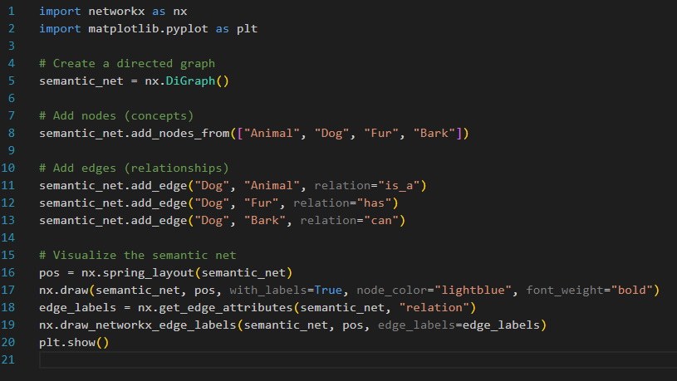

Output:

